**NEWSPAPER REPORT**

**Report Writing**

Report writing is a formal way of writing in-depth about a subject. A report’s writing style and tone are always formal.

A report is a written account of something that one has observed, heard, done, or investigated. It is a systematic and well organised presentation of facts and findings of an event that has already taken place somewhere

**Report Writing Format for a Newspaper**

**Headline-** A descriptive title which is expressed the news in short.

**Byline-** Name of the person writing the report along with the designation. It is generally given in the question. Remember, you are not supposed to mention your personal details in your answer.

**Place and date of reporting**- It is generally not mentioned in a magazine report separately, but in a newspaper report, you have to.

**Opening paragraph**- It includes an expansion of the headline.  It needs to be short as it is a general overview of the report.It can include the ‘5 Ws’ namely, WHAT, WHY, WHEN, and WHERE along with WHO was invited as the chief guest.

**Account of the event in detail**– It is generally written in two parts: First, a complete account of what happened in its chronological sequence (preferably), and second, the witness remarks.

**Concluding paragraph**- This will include the action that has been taken so far or that will be taken. It is the last paragraph of the report....

Write a report on an incident that took place in the Kinnaur district of Himachal Pradesh. Five people lost their lives during a car accident in the city. As per reports, all five were heavily injured and found dead after 1 hour of reaching the hospital. After 20 minutes of the accident, they were rushed to a nearby government hospital. The incident took place at 5 in the morning. The accident led to a traffic jam, following which the car was removed from the road by the police superintendent of Kinnaur Police Station and his team.

**Heading: Five killed in car accident in Kinnaur of HP**

Byline: By Kiran Kumar

Place and date: Kinnaur, May 23

First Para: Five people were killed in a car crash in Kinnaur district of Himachal Pradesh, this morning. According to sources, the time of the accident was 5 in the morning. Victims were rushed to a nearby hospital after 20 minutes by a resident crossing by the spot of the accident. After one hour of reaching the hospital, all five people were declared dead by the senior doctor of the hospital.

The details of the accident are still awaited. No confirmation on the cause of accidents has come from the police as of now. It is being said that the traffic jam caused by the accident brought the police’s attention to the matter and the residents of the place. The Police Superintendent, along with this team, rushed to the accident spot and removed the vehicle to clear out the jam.

According to sources, accidents in the area have been increasing since the start of the month. The Police Superintendent of the Kinnaur Police Station said, “ We are trying to address this matter on priority. There has been an increase in the number of accidents since the start of this month. We have built a team of six people who will investigate the case”.

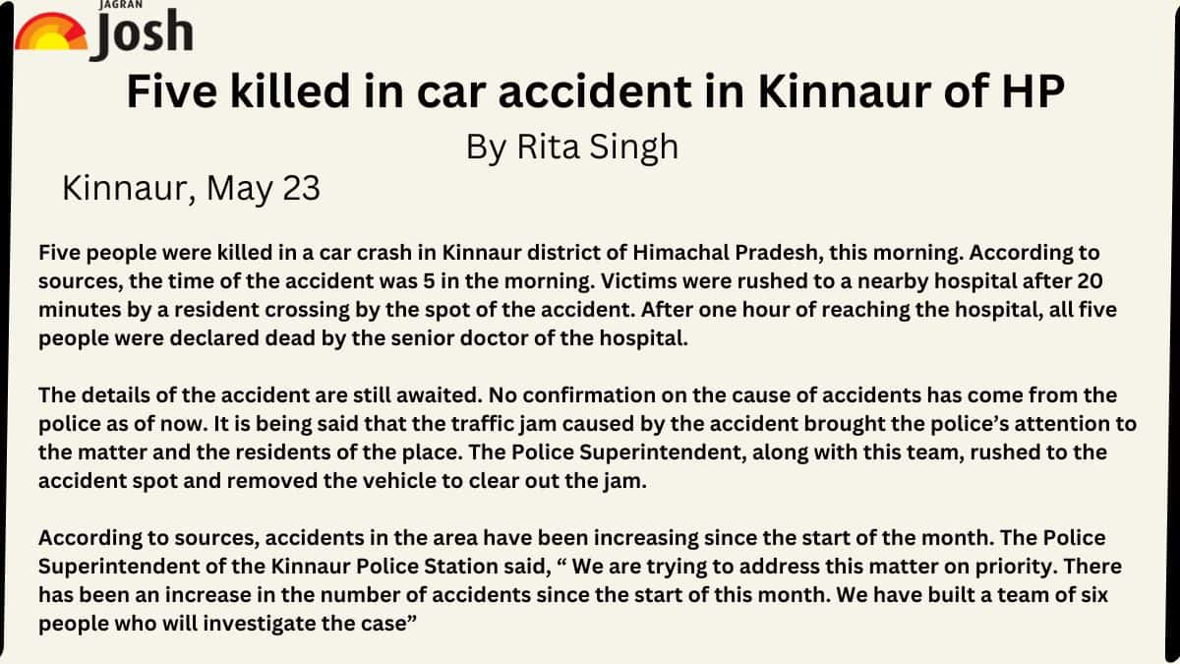

1. Write a report for a newspaper about A Terrible Train Accident.

**Odisha Train Accident / Coromandel Express Train Accident**

**By Staff Reporter**

Balasore, 3rd June 2023: At around 7 pm, 2nd June on Friday evening 10-12 coaches of the Shalimar-Chennai Coromandel Express derailed near Baleswar and fell on the opposite track. After some time, another train from Yeswanthpur to Howrah dashed into those derailed coaches resulting in the derailment of its 3-4 coaches. The train crash involving two passenger trains and a goods train in Odisha’sBalasore on Friday is said to be one of the deadliest rail accidents in India. More than 230 people have lost their lives in the accident and 900 have been injured. NDRF, ODRAF, and Fire Services are still working to cut the bogie and try to recover the living or the dead. Local people were seen helping the teams responsible for rescue and relief operations and they queued up to donate blood for the injured in Balasore. As a result, Local people became able to rescue 200-300 injured people A high-level committee has been declared to conduct an inquiry into the train accident. The Centre has announced an ex-gratia compensation of Rs 10 Lakh each to the kin of the deceased and Rs 2 Lakh to grievous and Rs 50,000 for minor injuries, Union Railways Minister AshwiniVaishnav said.

2. Write a report for a newspaper about A Magic Show.

**Magic Show**

**By AnikDutta**

On Friday, November 18: our school authority invited a magician to surprise the students of the school with a magic show. The magic show was a gift to the students from the school’s authoritative body as the school won the award for Best Disciplined School in Kolkata for the year 2015. The magic show was organized on the school’s open-air stage. The show went on for 2 hours, from 12 to 2 pm. The first magic shown by the great magician was pulling out of a rabbit from his hat which was absolutely empty when he wore it. The spectators were pleasantly surprised. He showed exciting magic tricks one after the other and ended the show with a message to the awestruck students, ‘Practice maths well, and you can do magic too as it is nothing but a game of calculation’. The show was immensely appreciated by all.

3. Write a report for a newspaper about Health Issues of the people of your District.

**Health Issues of the People of Your District**

**By Ravi Yogi**

On 20 May 2021: a health awareness campaign camp was organized in the Howrah district by the World Health Organisation. Some volunteers were chosen, who from then on, visit each house every month to remind people to get their children vaccinated. People now follow their instructions and keep their surroundings clean to avoid certain diseases. The volunteers distributed water purifiers at a cheap rate so that people could use them to get pure water. The mosquito-repellant sprays are used every month and mosquito nets are now used to keep mosquitoes away. If the volunteers arrange a blood donation camp every month it could help the people in need. Also, a free health checkup camp could be arranged for further health improvement of the people of the locality.